CG-Assignment
Midpoint Circle and Ellipse Algorithms

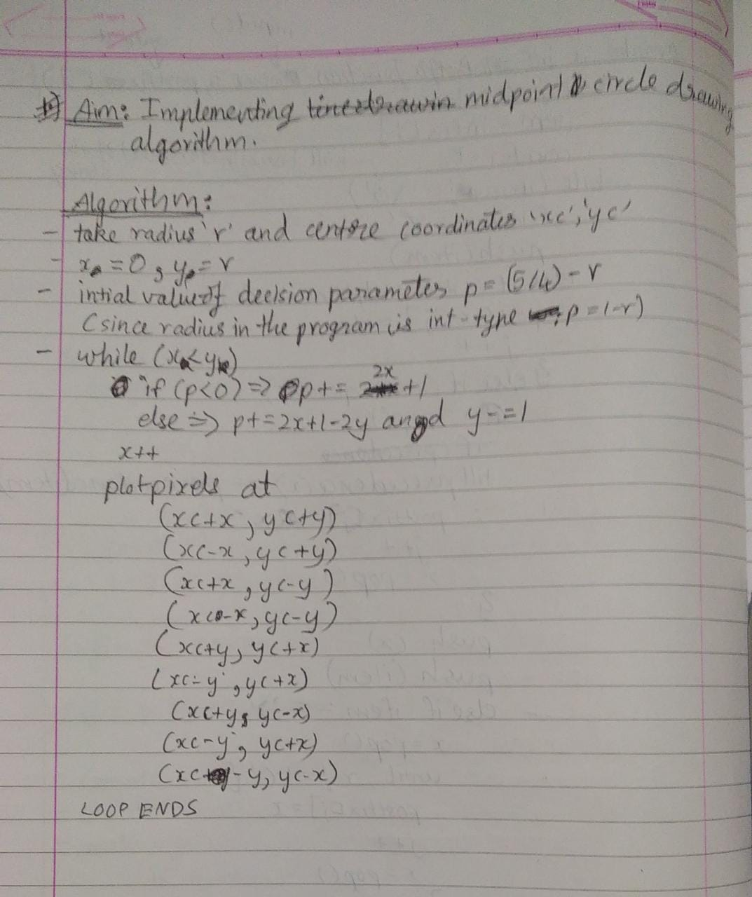

Program:
Drawing circles using midpoint circle algorithm

Code:

#include<stdio.h>
#include<graphics.h>
#include<conio.h>

void plotPoints(xc,yc,x,y){
putpixel(xc+x,yc+y,WHITE);
putpixel(xc-x,yc+y,WHITE);
putpixel(xc+x,yc-y,WHITE);
putpixel(xc-x,yc-y,WHITE);
putpixel(xc+y,yc+x,WHITE);
putpixel(xc-y,yc+x,WHITE);
putpixel(xc+y,yc-x,WHITE);
putpixel(xc-y,yc-x,WHITE);
}

void mpcircle(int xc, int yc, int r){
int x,y,p;
x=0;
y=r;
p=1-r;

plotPoints(xc,yc,x,y);

while(x<y){
x++;
if(p<0){
p+=2*x+1;
}else{
y--;
p+=2*(x-y)+1;
}
plotPoints(xc,yc,x,y);
}

}

void main(){
int gd = DETECT,gm;
int xc,yc,r;
initgraph(&gd,&gm,"c:\\turboc3\\bgi");
printf("Enter the cneter coordiantes(x,y)\n");
scanf("%d%d",&xc,&yc);
printf("Enter the radius of the circle\n");
scanf("%d",&r);
printf("\nHriday Keswani\nRoll no. 20003088\n");
mpcircle(xc,yc,r);
getch();
closegraph();
}

Output:

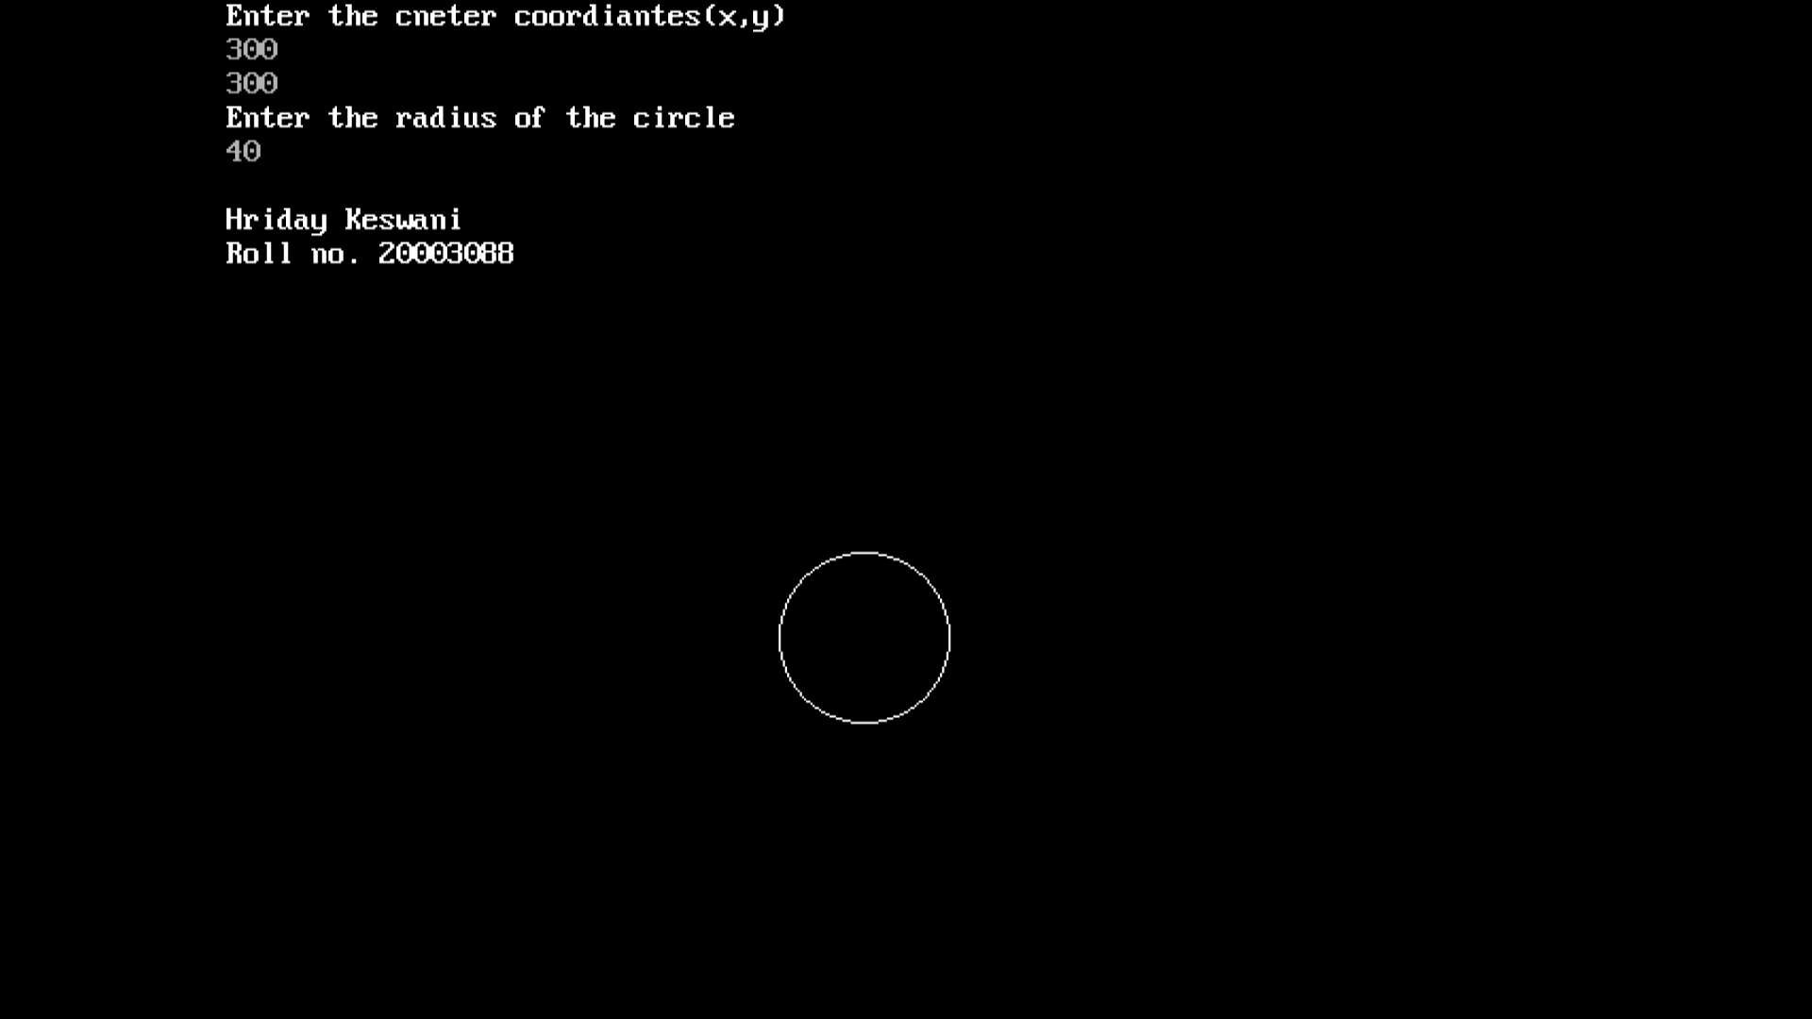

Program:
Drawing concentric circles midpoint circle algorithm
Code:

#include<stdio.h>
#include<graphics.h>
#include<conio.h>

void plotPoints(xc,yc,x,y){
putpixel(xc+x,yc+y,WHITE);
putpixel(xc-x,yc+y,WHITE);
putpixel(xc+x,yc-y,WHITE);
putpixel(xc-x,yc-y,WHITE);
putpixel(xc+y,yc+x,WHITE);
putpixel(xc-y,yc+x,WHITE);
putpixel(xc+y,yc-x,WHITE);
putpixel(xc-y,yc-x,WHITE);
}

void mpcircle(int xc, int yc, int r){
int x,y,p;
x=0;
y=r;
p=1-r;

plotPoints(xc,yc,x,y);

while(x<y){
x++;
if(p<0){
p+=2*x+1;
}else{
y--;
p+=2*(x-y)+1;
}
plotPoints(xc,yc,x,y);
}

if(r>10){
r-=10;
mpcircle(xc,yc,r);
}

}

void main(){
int gd = DETECT,gm;
int xc,yc,r;
initgraph(&gd,&gm,"c:\\turboc3\\bgi");
printf("Enter the center coordiantes(x,y)\n");
scanf("%d%d",&xc,&yc);
printf("Enter the radius of the circle\n");
scanf("%d",&r);
printf("\nHriday Keswani\nRoll no. 20003088\n");
mpcircle(xc,yc,r);
getch();
closegraph();
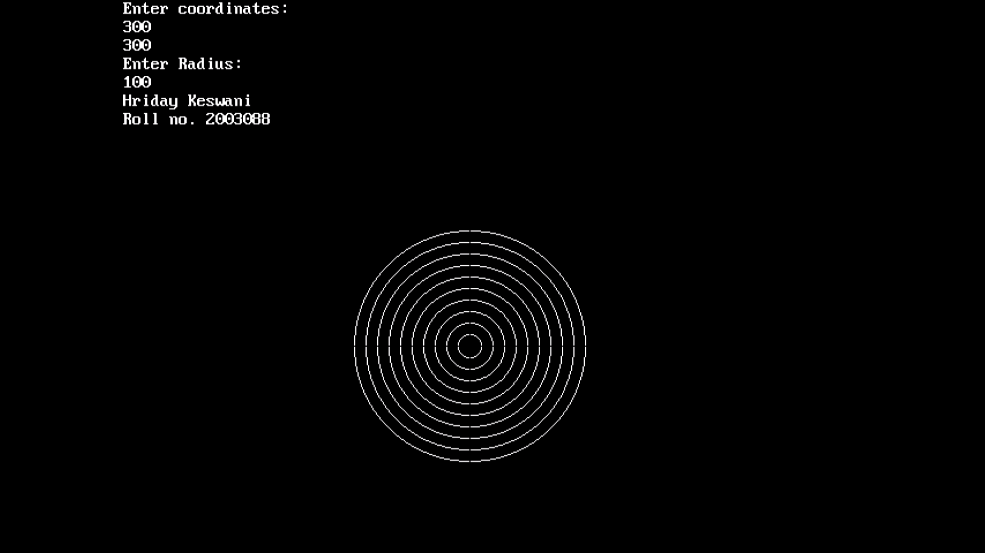
}
Output:

Program:
Drawing ellipse from midpoint ellipse algorithm

Theory:

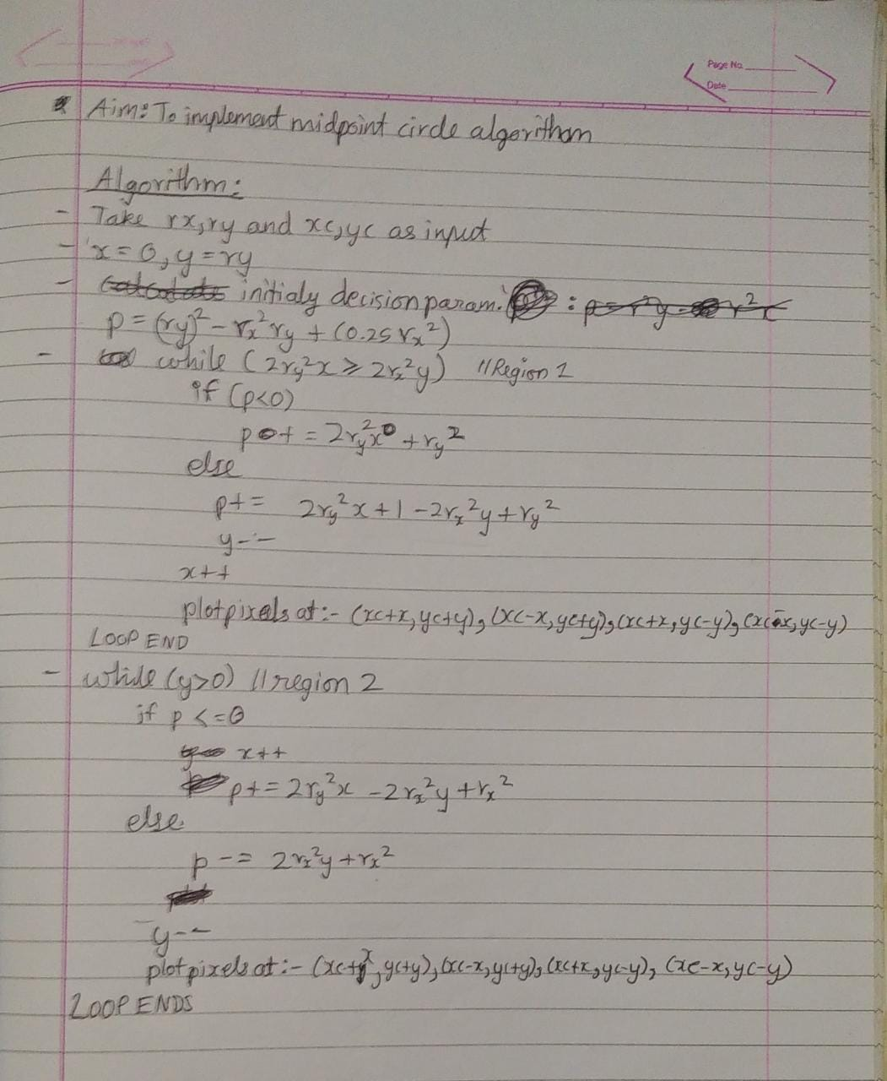

Code:

#include<stdio.h>
#include<graphics.h>
#include<conio.h>

void main(){
int gd = DETECT,gm;
int xc,yc,x,y;
long rx,ry;
float p;

initgraph(&gd,&gm,"C:\\TURBOC3\\BGI");
clrscr();

printf("Enter the center coordinates:\n");
scanf("%d%d",&xc,&yc);
printf("Enter Rx and Ry:\n");
scanf("%ld%ld",&rx,&ry);
printf("\nHriday Keswani\nRoll no. 20003088\n");

p = ry*ry-(rx*rx*ry)+(0.25*rx*rx);
x=0;
y=ry;

while(2.0*ry*ry*x <= 2.0*rx*rx*y){
if(p<0){
x++;
p = p+2*ry*ry*x+ry*ry;
}else{
x++;
y--;
p = p+2*ry*ry-2*rx*rx*y-ry*ry;
}
putpixel(xc+x,yc+y,WHITE);
putpixel(xc-x,yc+y,WHITE);
putpixel(xc+x,yc-y,WHITE);
putpixel(xc-x,yc-y,WHITE);
}

p = ry*ry*(x+0.5)+rx*rx*(y-1)*(y-1)-rx*rx*ry*ry;

while(y>0){
if(p<=0){
x++;
y--;
p = p+2*ry*ry*x-2*rx*rx*y+rx*rx;
}else{
y--;
p=p-2*rx*rx*y+rx*rx;
}
putpixel(xc+x,yc+y,WHITE);
putpixel(xc-x,yc+y,WHITE);
putpixel(xc+x,yc-y,WHITE);
putpixel(xc-x,yc-y,WHITE);
}
getch();
closegraph();
}

Output:

